**Tackling Indigenous Smoking Manager**

**Closing Date: 5pm Friday, 21 July 2023**

**The Organisation**

Galambila Aboriginal Health Service, Bullinah Aboriginal Health Service Limited and Awabakal Aboriginal Health Service are partnering to deliver Tackling Indigenous Smoking activities for the Aboriginal communities along the central, mid, and north coasts of NSW.

**Important Information**

This is a full-time contract to 30 June 2025 ideally located in Coffs Harbour, however home location may be negotiated at either Newcastle or Ballina.

Galambila is an equal opportunity employer and all applications for vacancies are based on merit. Women and people with disabilities are encouraged to apply.

Please note Galambila Aboriginal Health Service considers that being Australian Aboriginal is a genuine occupational qualification under s.14 of the Anti-Discrimination Act 1977 NSW – the successful applicant will need to provide documentation that they are recognised by the Aboriginal Community as being of Aboriginal descent.

Galambila provides a smoke-free work environment and promotes a no-smoking culture for staff where they are encouraged and supported not to smoke. Smoking is not permitted at any time in the buildings of the workplace or vehicles of Galambila.

All employees must have received two completed COVID-19 vaccinations prior to commencement.

**Salary**

Galambila offers the following salary package:

* Base salary commencing $105,000 to $115,000 – appointment will occur based on previous skills and experience;
* Additional 5 days sick leave per year;
* Additional leave for NAIDOC and Christmas; and
* Monthly rostered days off.

**How to apply**

To apply for this role you will need to provide:

* A completed Applicant Details Form;
* Your updated Resume; and
* A maximum two-page cover letter addressing the capabilities relevant to the role.

You can submit your application directly by email to [HR@Galambila.org.au](mailto:HR@Galambila.org.au) or online at [www.galambila.org.au/careers](http://www.galambila.org.au/careers).

For further information or enquiries please ring Jane or Naomi on 02) 6652 0800

Late applications will not be considered for interview.

Applications must be received on or before **5pm Friday, 21 July 2023**

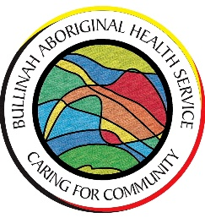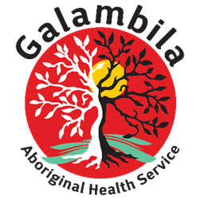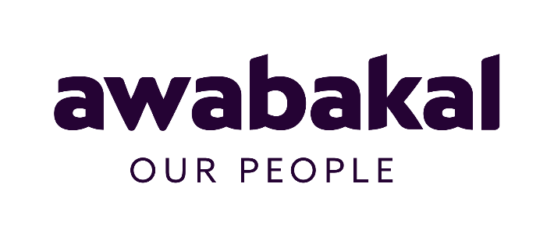

**APPLICANT DETAILS**

**Position Applied for**

Tackling Indigenous Smoking Manager

**Name**

Click here to enter text.

**Do you identify and are recognised as Aboriginal or Torres Strait Islander?**

Yes, Aboriginal  Yes, Torres Strait Islander  Yes, Aboriginal and Torres Strait Islander

No, I don’t identify as either Aboriginal or Torres Strait Islander

**Address**

Click here to enter text.

**Suburb, State and postcode**

Click here to enter text.

**Contact Number Alternative Contact Number**

Click here to enter text. Click here to enter text.

**Email address**

Click here to enter text.

**How did you hear about this vacancy?**

Choose an item.

If other, please detail: Click here to enter text.



**Tackling Indigenous Smoking Manager**

Please note Galambila Aboriginal Health Service considers that being Australian Aboriginal is a genuine occupational qualification under s.14 of the Anti-Discrimination Act 1977 NSW – the successful applicant will need to provide documentation that they are recognised by the Aboriginal Community as being of Aboriginal descent.

**Essential**

**Partnerships and collaboration**: Develops models and protocols for working in formal and informal partnerships with stakeholders to achieve and improve client outcomes.

**Initiative and Enterprise:** Encourages teams to show initiative and looks for ways to work more dynamically.

**Communication Written and Verbal:** Writes accurate, succinct reports and documents for CEO’, funding bodies and key stakeholders, and provides considered responses and clear messages to inspire trust and confidence of others.

**Leadership and Teamwork:** Champions vision and mission and maintains a focus on the big picture.

**Program Development:** Manages programs and complex programs to work to timelines, budget and achieve goals and objectives. Envisions and designs new programs and establishes targets.

**Service Delivery:** Knowledge of community issues, maintains high level awareness of community issues as impacted by social determinants of health.

**Technology**: Utilises new technologies and systems to strengthen organisational effectiveness and improve team performance.

**Desirable**

1. Experience in an Aboriginal Community-Controlled Health Service
2. Experience in leading or line managing a team

**Licence**

Current ‘C’ Class driver’s licence is mandatoryfor this role.

**Qualifications**

There are no mandatory qualifications for this role, however the following qualifications are highly regarded:

* Bachelor of Public Health and Health Promotion or equivalent; or
* Graduate Certificate in Indigenous Health Promotions

**Employment Arrangements**

An offer of employment is subject to a six (6) month probationary period. This role is advertised as a fixed term contract through to June 2025. Continuation in the role is subject to funding and satisfactory performance. A review of performance will be conducted 3 months after commencing. All staff undertake individual Performance Agreements including regular reviews. Your reporting lines may change from time to time at Galambila in accordance with operational requirements.

This appointment is subject to a satisfactory clearance for a police check and a clearance for working with Children undertaken by the Office of the Children’s Guardian (NSW).



**Position Description**

|  |  |
| --- | --- |
| Position: | Tackling Indigenous Smoking Manager |
| Location: | Coffs Harbour – however home location may be negotiated at Ballina or Newcastle |
| Pay structure: | Galambila General Enterprise Agreement 2017 |
| Annual Salary | $105,000 - $115,000 |
| Hours per week | 38 |

|  |
| --- |
| Our Values → Respect ↔ Accountability ↔ Inclusive ↔ Compassionate ↔ Empowerment |
|  |
| Our Purpose → Culturally appropriate care that ensures the best possible health and wellbeing outcomes for those on Gumbaynggirr Land |
|  |
| Our Vision → Greater choices for our mob to improve health for all stages of life |

**Objectives**

In this role you will develop and maintain purposeful partnerships to implement a community approach impacting smoking and vaping rates across our regions.

**Key Areas of responsibilities**

Lead and manage a geographically dispersed Tackling Indigenous Smoking workforce emphasising capacity building for health promotional activities in the team.

Develop and maintain purposeful partnerships across the region. Focusing on empowering communities attitudes towards reducing the incidence of smoking and vaping.

Engage with community and stakeholders to deliver a regional response that is locally informed to address smoking and vaping.

Identify underserviced communities to implement targeted activities that are culturally relevant to their area.

Manage the health promotion campaign across the regions utilising social media, billboards, community newsletters and promotional products.

Identify and deliver health promotion campaigns addressing vulnerable priority groups including youth, during pregnancy and Elders.

Develop and maintain smoking and vaping cessation referral pathways to trusted quit partners.

Develop and implement reporting activities for the Regional Tackling Smoking workforce managing compliance with funding obligations.

**Workplace responsibilities**

* Work as a team member, seeking support, guidance and direction as required;
* Provide leadership, direction, support and supervision to all direct reports;
* Attend meetings and undertake training as appropriate to the role of Network Coordinator – Suicide & Social and Emotional Wellbeing;
* Perform any other duties consistent with the terms of employments as may be directed or implied from time to time; and
* Participate in staff performance reviews.

**Workplace Health and Safety responsibilities**

* Follow defined WH&S and injury management policies and procedures;
* Take reasonable care for the safety of others in the workplace;
* Ensure organisational compliance with any requirements of the WH&S Act and other legislation with regard to health, safety and welfare in the workplace;
* Not intentionally or recklessly interfere with or misuse anything provided in the interests of health, safety and welfare in compliance with the WH&S Act or other legislation;
* Report all accidents or incidents which did, or could have resulted in, injury to others in the workplace or damage to property;
* Report all hazards or potential hazards;
* Be familiar with emergency evacuation procedures and participate in regular training in safety procedures; and
* Provide input into regular safety inspections for their department.

**Child Protection Responsibilities**

* Be familiar with and adhere to legislation in relation to Child Protection and comply with NSW Health Frontline Procedures for the Protection of Children and Young People; and
* Attend training in Child Protection as required.

**Continuous Quality Improvement responsibilities**

* It is the responsibility of each staff member to be aware of the contents of the policy and procedures manuals and work within the principles contained therein.
* Each staff member is expected to be committed to quality service and to participate in activities to enhance continuous quality improvements in the workplace.

**Non Smoking Policy**

Galambila provides a smoke-free work environment and promotes a no-smoking culture for staff where they are encouraged and supported not to smoke.



**Galambila Privacy and Confidentiality information**

One of the many rules to which staff must strictly adhere is the rule of professional secrecy and access to confidential information. All Galambila employees must observe a strict code of secrecy in any matters relating to work at Galambila and particularly in relation to information regarding clients/patients.

It is equally important that members of staff do not disclose any health information of clients/patients to any other staff member unless this information is necessary for the provision of care and is exchanged in the course of providing care.

Matters concerning the work of Galambila including information about clients/patients must never be discussed outside of Galambila and each member of staff has a moral and legal obligation to Galambila not to violate the trust placed in them in the handling of sensitive and confidential client and organisation information.

Staff recruited to Galambila are required to sign privacy and confidentiality agreements upon commencement of employment. Breaches of privacy and confidentiality are treated with the utmost seriousness and may result in disciplinary action up to and including termination of employment.

**Employment Arrangements**

An offer of employment is subject to a six (6) month probationary period. This role is advertised as a fixed term contract (up to June 2025). Continuation in the role is subject to funding. A review of performance will be conducted 3 months after commencing. All staff undertake individual Performance Agreements including regular reviews. Your reporting lines may change from time to time at Galambila in accordance with operational requirements.

This appointment is subject to a satisfactory clearance for a police check and a clearance for working with Children undertaken by the Office of the Children’s Guardian (NSW).

Galambila has a mandatory COVID vaccination policy, all successful candidates must have completed two doses of a COVID vaccine prior to commencement, or be able to provide a medical contraindication form for an ongoing medical contraindication to approved COVID vaccines.

**Documentary identification required**

**Successful applicants** will be required to provide the following documentation:

* Working with Children Check verification or application number;
* Proof of two COVID-19 vaccinations or a completed medical contraindication from a medical practitioner;
* Proof of identity (such as Birth Certificate, Drivers licence, Proof of Age Card, or Passport); and
* Confirmation of recognition of being of Aboriginal and/or Torres Strait Islander descent from an incorporated Aboriginal and/or Torres Strait Islander organisation.